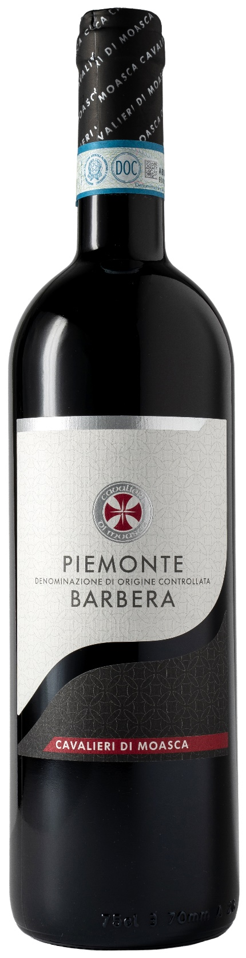
BARBERA PIEMONTE DOC – CAVALIERI DI MOASCA

Grape: Barbera 100%
Alc. Vol.%: 13
Vintage: 2024
Residual sugar g/l: 6,5
Total acidity g/l: 5,6
Region: Piedmont
Production zone: Vineyards in the area of Moasca, Agliano and Mombaruzzo (Asti)
Capacity: 750ml

CHARACTERISTICS

Vinification: Traditional peel maceration at a controlled temperature for 10 days
Aging: 6 months in steel tanks
Yield per ha: 11000kg
Colour: Intensive red with purple reflections
Bouquet: Fruity and winy with hints of spices
Flavour: Dry but smooth at the same time, full-bodied with noble tannins

SERVING SUGGESTIONS

Best enjoyed with pasta, ripe cheese, grilled meat and game.
Serving temperature 18 °C
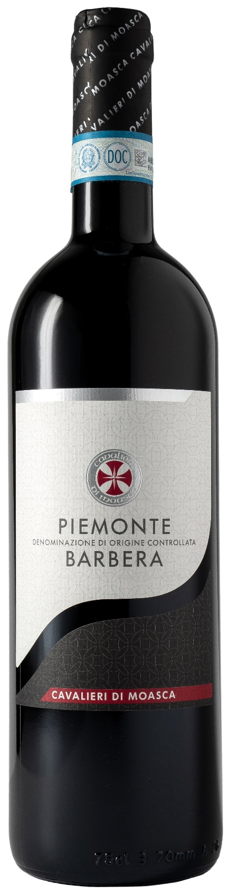
TECHNICAL INFORMATION / PALLETIZING

Size 750ml:
Article Nr. V06004A
GTIN-13 bottle 8017868003045
GTIN-13 carton 8017868001942
Closure Cork
Bottles / carton 6 bottles
Pallet size 80x120cm
Cartons/layer 24
Cartons/pallet 120
Kg/carton 7,8
Kg/pallet 958

Contains sulphites
GMO Free
Revisione 01. 21.04.2026

